**TECHNO Sales Data Analysis for (2020-2022)**

# Introduction

This repository contains data and analysis on Sales of Techno company for the years 2020 to 2022. The data has been collected from official sources and is intended for research and informational purposes.

Problem Statement:

The objective of this project is to conduct a comprehensive analysis of techno sales data from 2020 to 2022, with a focus on several key dimensions:

* **Sales by Category**: Investigate the quantity sold within each product category over the specified period to identify trends, popular products, and areas for potential growth.
* **Total Sales by Brand**: Determine the total sales revenue generated by each brand represented in the dataset, highlighting the top-performing brands and potential areas for improvement.
* **Geographical Analysis**: Analyze sales data across different states in India to understand regional variations in sales performance, identify high-potential markets, and tailor strategies accordingly.
* **Sales Performance by Supervisors**: Evaluate the sales performance of different supervisors or sales representatives, identifying top performers, areas needing improvement, and factors contributing to success.
* **Identifying Insights**: Explore additional insights within the dataset such as seasonality effects, correlation between marketing campaigns and sales, customer preferences, and any outliers or anomalies that require further investigation.

The ultimate goal is to provide actionable insights to the company's management team, enabling informed decision-making, targeted marketing strategies, and enhanced sales performance across various dimensions of the business.

## Data Sources

* TECHNO Sales Data for (2020-2022) for India has been sourced from Kaggle.

### Step Followed

Step 1 : Load data into Power BI Desktop, dataset is a csv file.

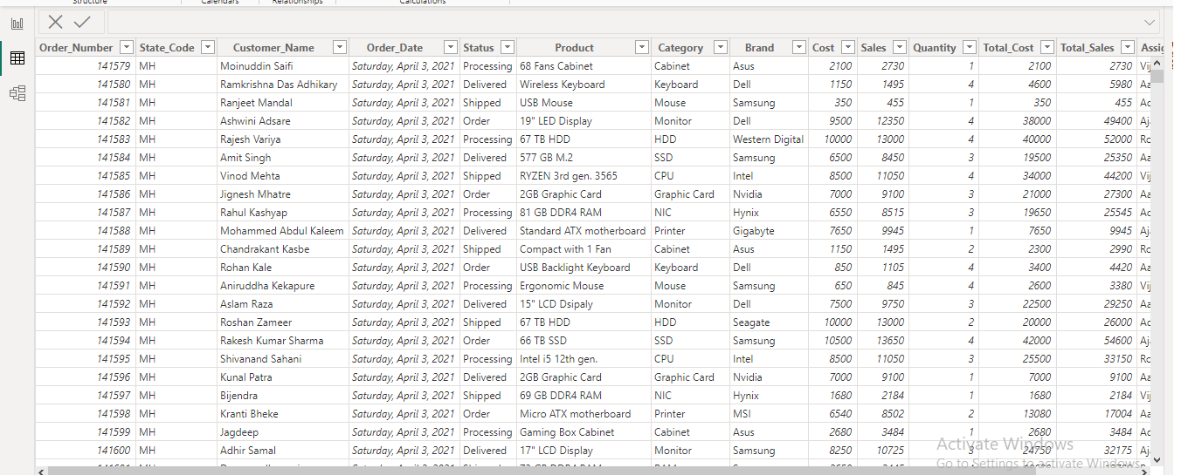

* Step 2 : Open power query editor & in view tab under Data preview section, check "column distribution", "column quality" & "column profile" options.
* Step 3 : In Power Query Editor we also handled missing values appropriately ,and also removed any duplictes values which were there, we also change the data type where ever is required.
* Step 4 : After that it was observed that in none of the columns errors & empty values were present.
* Step 5 : In the report view, under the view tab, theme was selected.
* Step 6 : To represent the sum of total sales and total cost of products we use card .

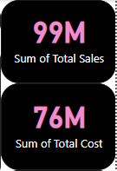

* Step 7 : To represent The sum of quantity and Count of order no. again we had used card.

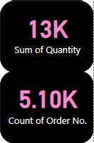

* Step 8 : To represent Sales of quantity by Category we had used Stacked column chart.

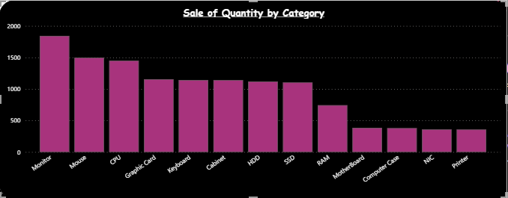

* Step 9 : To represent Total sales by different different brand we had used Pie Chart.

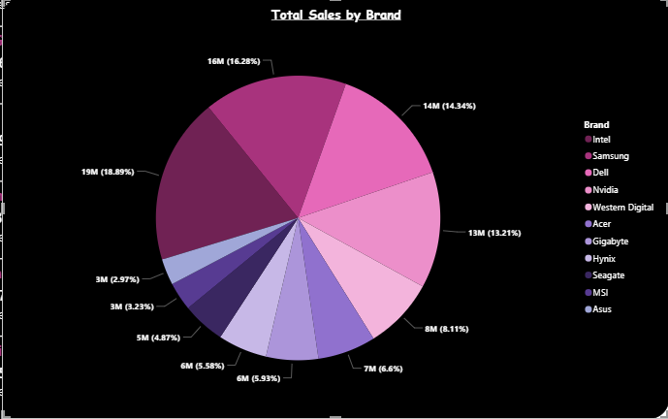

* Step 10 : To find out Total sales of Techno in different- different states of india we had used Map Chart.

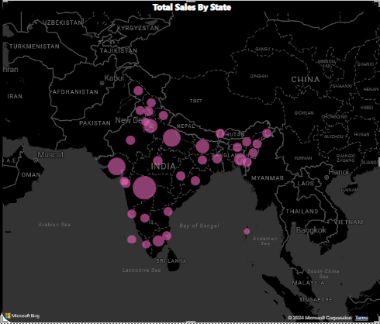

* Step 11 : To get an idea about performance of each supervisor we had used Multi Row Card to represent their total sales between year (2020-2022).

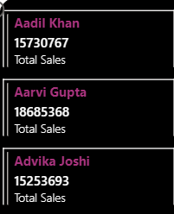 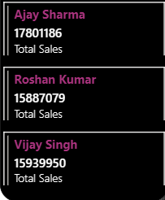

**Dashboard After Completion :**

* After Completion dashboard looks like this.

